

MUMBAI EDUCATIONAL TRUST
MET INSTITUTE OF COMPUTER SCIENCE

Program Number | 01
Roll Number | 1550
Title of program | MongoDb basic Commands
Objective | Perform basic operation in MongoDB Database
Section 1-Data Defination
1)Create a Database
Use database-name-to create database if database already exist is switches to database

show databases-show databases
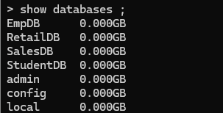
2) Creating a Collection- Dynamically-group of documents
1)insert()
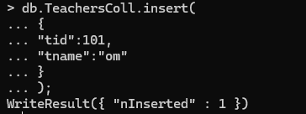
2)insertOne()
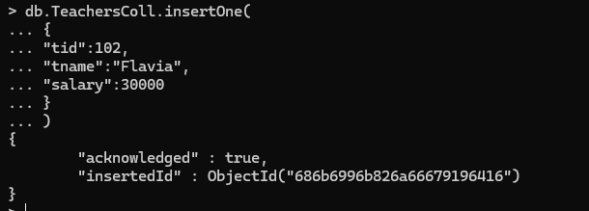
3)insertMany()
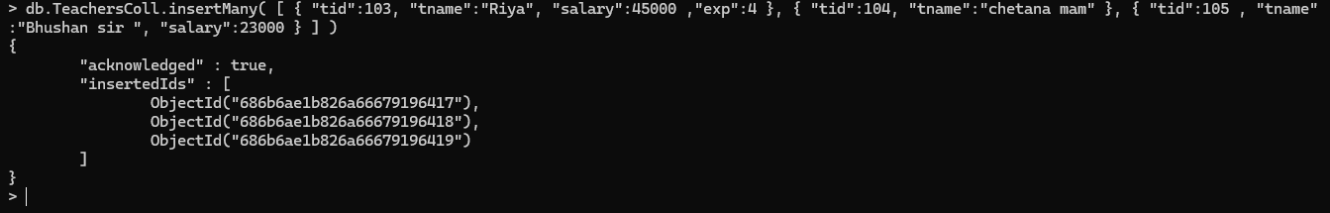

4)find()-to display the document from collection
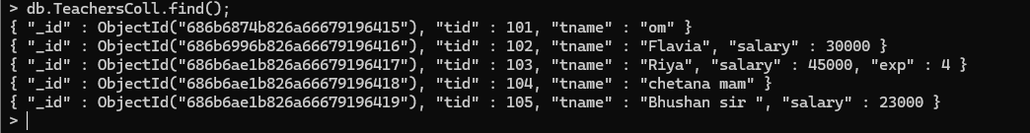
5)find().pretty()
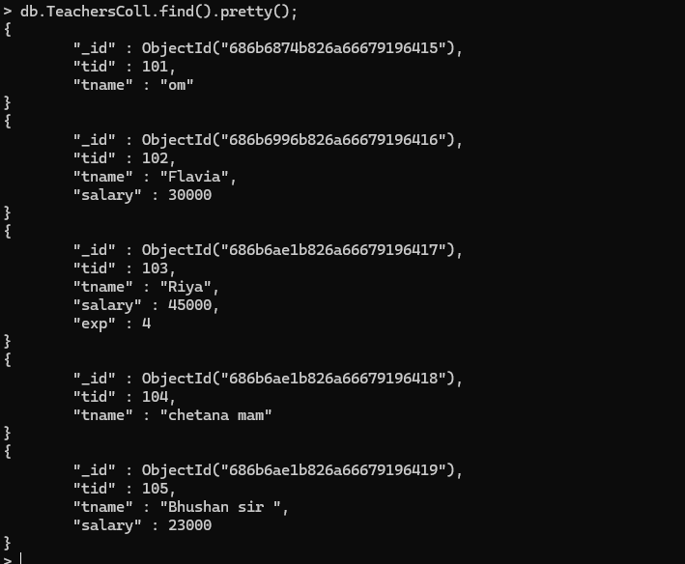

3)Creating a Collection Statically- Creating a collection statically means explicitly creating it before inserting any documents

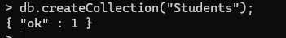


2)insertOne()
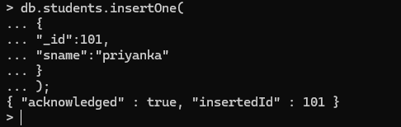

In MongoDB, it is not compulsory to manually define an _id field when inserting a document.

3)Find().pretty()


Section 2-Data Manipulation
Select-projection-vertical
Where -selection-horizontal
MongoDB Comparison Operators
1)$gt-greater than
2)$lt-less than
3)$gtlt-greater than or less than
4)$lte-less than or equal to
5)$ne-not equal to

1)Write a query find all the teacher earning salary greater than 30000

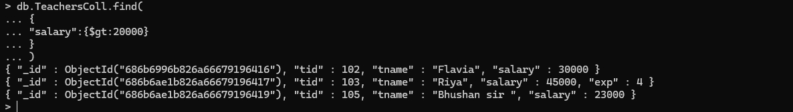
2)Write a query find all the teacher earning salary less than 50000

3)Write a query find all the teacher earning salary greater than or equal to 30000
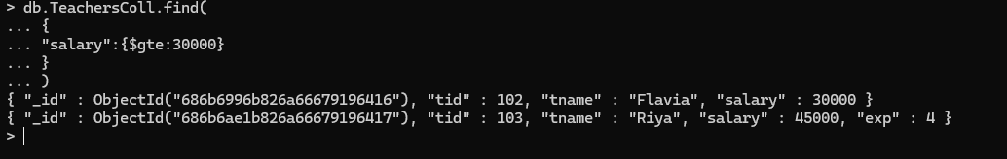
4)Write a query find all the teacher earning salary less than or equal to 23000
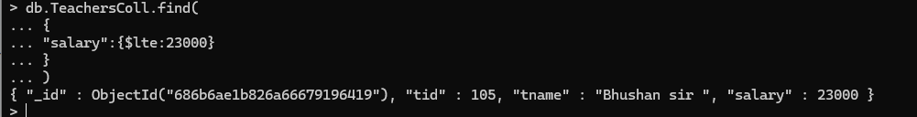
5)find details with teachers and id 103

6))find details with teachers and not equal to id 103
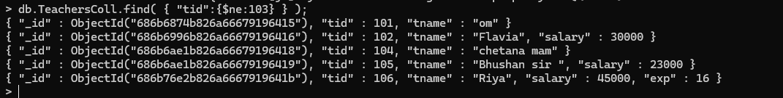

7)write a query to find all the employee whose salary is greater than 3000 or experience is greater than 16
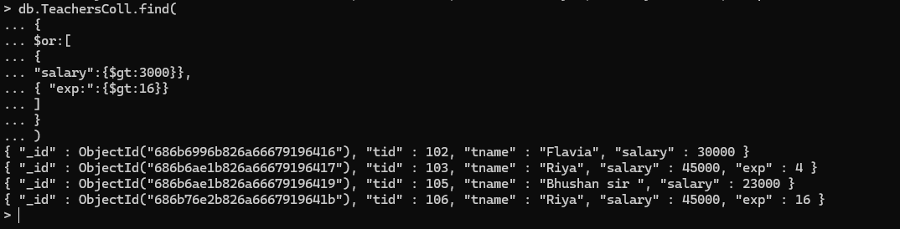
8)write a query to find all the employee whose salary is greater than 3000 and experience is greater than 16
